For Immediate Release

Māori Climate Commissioner: Current heatwave grim view of climate change future

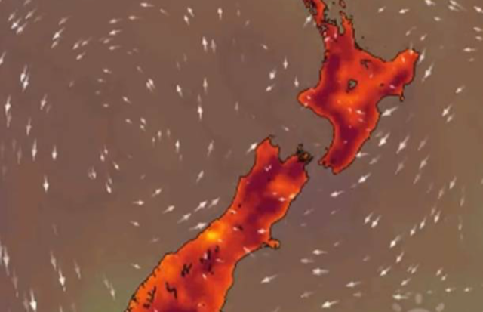

Māori Climate Commissioner, Donna Awatere Huata, says the current heatwave that burnt Australia and is currently suffocating New Zealand is a grim view of our climate change future.

"The 2016 Ministry for the Environment report on climate change and its impact on New Zealand clearly states that the projections beyond 2040 will see an increase in drought severity, an increase in heatwaves and an increase in severe weather events."

"What we are experiencing after the hottest year on record is a record breaking heatwave, this is our future and it is happening now. Without immediate leadership from politicians and industry we will not adapt fast enough for the economy or society."

"When we are seeing extreme climate change like this occurring now, being carbon neutral by 2050 is not a solution. It's an abdication of responsibility."

For all media enquiries please contact:
Donna Awatere Huata
Māori Climate Commissioner
021 196 4441

