For Immediate Release

Māori Climate Commissioner: West Coast Regional Council climate change ignorance is shameful

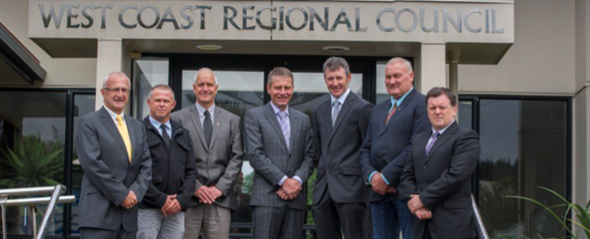

Māori Climate Commissioner, Donna Awatere Huata, says the ultimatum by West Coast Regional Council to see evidence human pollution is causing climate change before they reduce emissions is a shameful ignorance.
"The science is clear. As trapped heat from our emissions continues to build, westerly airflow across NZ will rapidly increase. That will bring more water to the West Coast and with the Southern Alps acting as a natural barrier, that water will fall as rain."

"The West Coast will face severe rain events that will increasingly wash away infrastructure and flood anything near rivers. That the West Coast Regional Council refuses to reduce emissions until they see evidence is shameful ignorance at best and anti-science book burning superstition at worst."
"The good people of the West Coast need leadership, not medieval stupidity."

For all media enquiries please contact:
Donna Awatere Huata
Māori Climate Commissioner
021 196 4441

