For Immediate Release

Latest research shows Antarctica now losing 252 billion tonnes of ice a year - Māori Climate Commissioner calls for urgent climate action now!

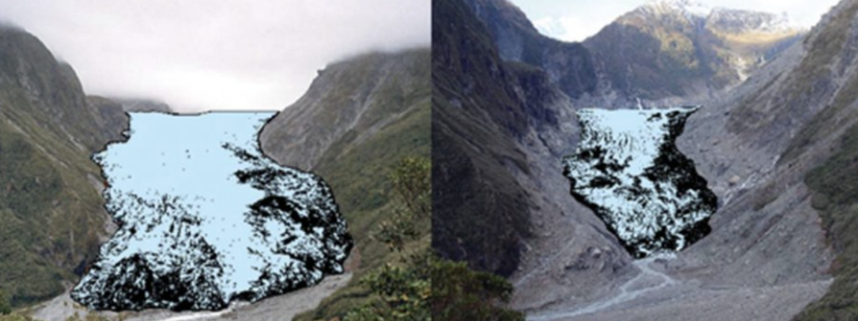

Māori Climate Commissioner, Donna Awatere Huata, has said the latest research from the U.S. journal Proceedings of the National Academy of Sciences (PNAS) shows we need urgent climate action now.
" The East Antarctic ice sheet is now melting adding to the increased losses we are seeing on the Western side. Between 1979-90 we were seeing an average net ice loss of 40 billion tonnes per year, that has rapidly accelerated to 252 billion per year on average between 2009-17."
"The climate crisis is here and it is now. Antarctica is a crucial link in that chain of events. As we see record heat waves striking Australia, recent wild fires in California and New Zealands hottest year on record, we must force our political system to push our economy, culture and communities into adaptation resilience."
“Our political system, like those of most of the rest of the signatories to the Paris agreement has the reaction time of the Titanic - ."

For all media enquiries please contact:
Donna Awatere Huata
Māori Climate Commissioner
021 196 4441

