For Immediate Release

Māori Climate Commissioner: It's time NZ children went on strike to shame adults over climate change inaction
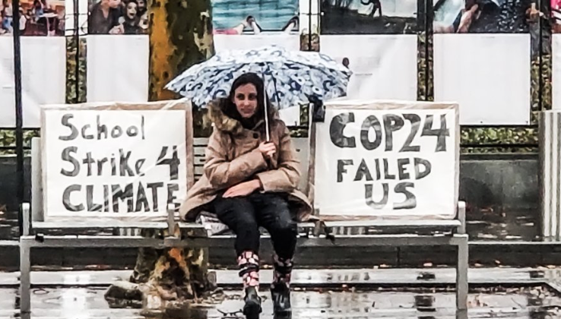
Māori Climate Commissioner, Donna Awatere Huata, says now is the time for Children to shame adults into climate change action.

"On March 15th, the movement of children striking from school to protest the inaction by adults on climate change finally reaches the shores of Aotearoa."

"Following in the footsteps of 15 year old Swedish climate campaigner Greta Thunberg and 13-year-old American Alexandria Villasenor, children around the planet are striking to protest against the failure by adults on a problem they will inherit as a poisoned legacy."

"As adults, we should be ashamed at our inaction and wilful delusion as every climate change alarm screams at us that we must make immediate change. If it takes our children to shame us from our apathy, so be it".
"I will join the children of Aotearoa on March 15th to stand in solidarity with their hope, their dreams and their future".

For all media enquiries please contact:
Donna Awatere Huata
Māori Climate Commissioner
021 196 4441

