For Immediate Release

Māori Climate Commissioner: Greenland melting is a grim new climate change warning

Māori Climate Commissioner, Donna Awatere Huata, says the latest research from Greenland is a grim new climate change warning.
"The study, published in Proceedings of the National Academy of Sciences, shows that since 2003, ice melt in Greenland has increased four-fold. That's almost 300 billion tons of ice per year and it's rapidly getting worse."
"This is dangerous for two reasons. The first is that previous studies had focused on ice loss from glaciers, while this research points out that ice mass is now melting as well'.
"The second reason this is dangerous is because one of the major pumps for the oceanic current flow which distributes heat from the tropics to the Northern Hemisphere is in the Labrador Sea, south of Greenland. A massive influx of fresh water would desalinate the Labrador pump and shut down the oceanic current. This would have catastrophic impact on climate alongside disastrous sea rise."
"The time for tinkering at the edges to adapt the economy has past, and our political system needs to be far more focused on immediate reform and solutions. To date we are seeing leadership that is asleep at the wheel of the Titanic."

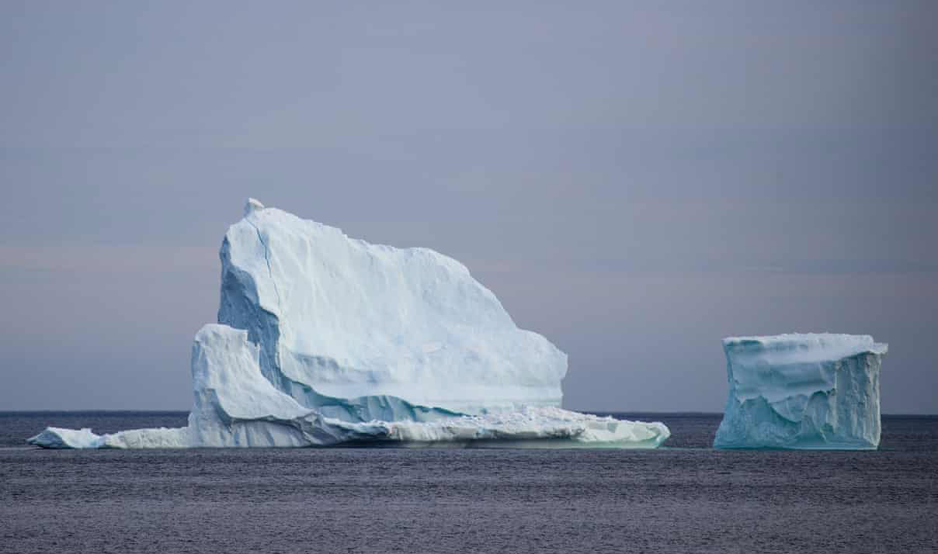

For all media enquiries please contact:
Donna Awatere Huata
Māori Climate Commissioner
021 196 4441

