For Immediate Release

New Zealanders must Challenge the Culture of Climate Denial
The Māori Climate Commissioner, Donna Aware Huata has called on New Zealanders to challenge the culture of climate denial.
"According to a 2015 study from the University of Tasmania, New Zealand has one of the highest levels of climate denial in the Western World with 13% of us not believing climate change is made by human pollution. Out of 14 Western developed countries, we came third behind Australia and Norway."
"Climate Change is no longer a scientific question, it has become a cultural one with those who benefit most from the current power dynamics refusing to accept or acknowledge the science."
"Muddying the science and injecting confusion are the same tactics the Tobacco industry used for decades and it is essential if we are to progress with the haste we need to adapt to the extremes of climate change to challenge climate deniers instead of let them spread disinformation."
"If we look at a Party break down from 2017, we see that it is National Party voters who are the greatest total number of voters who don't see climate change as a problem, we need to all work together to challenge lazy claims and ill thought out denial".
"The time for denial is over, the time for action is now and we must not allow deniers to hold back progress."
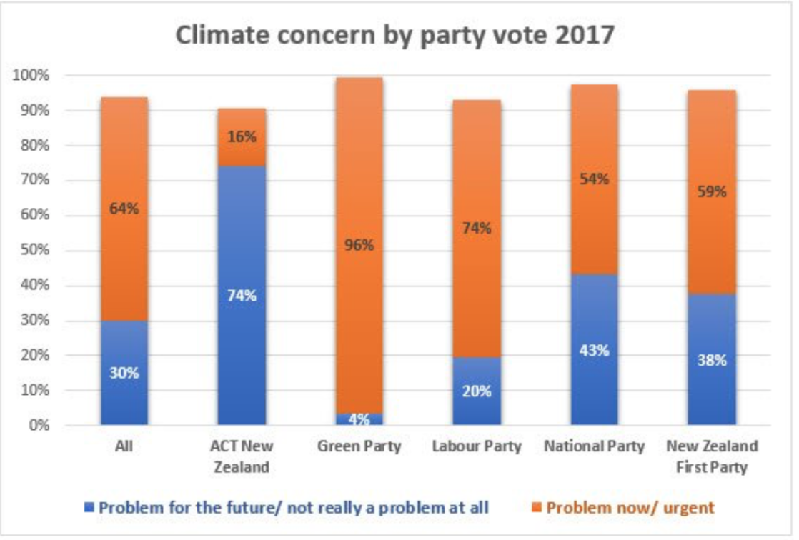
For all media enquiries please contact:
Donna Awatere Huata
Māori Climate Commissioner
021 196 4441

